# Part 1:

Write a program that uses nested loops to collect data and calculate the average rainfall over a period of years. The program should first ask for the number of years. The outer loop will iterate once for each year. The inner loop will iterate twelve times, once for each month. Each iteration of the inner loop will ask the user for the inches of rainfall for that month. After all iterations, the program should display the number of months, the total inches of rainfall, and the average rainfall per month for the entire period.

## Flowchart, Pseudocode

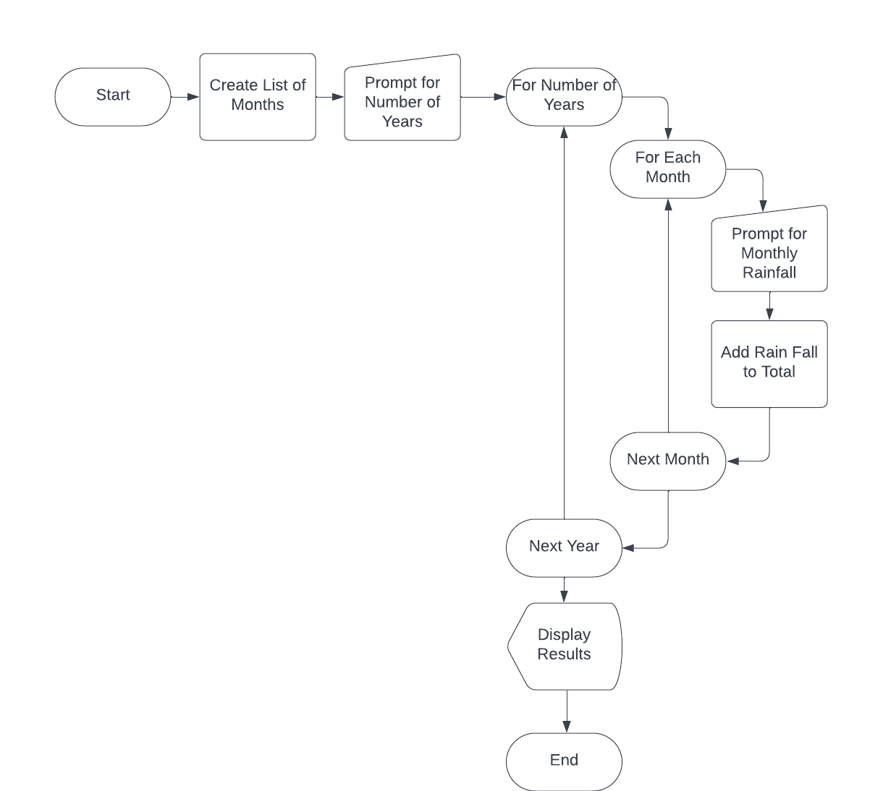

## Python Code

# Write a program that uses nested loops to collect data and calculate the average rainfall over a period of years. The program

# should first ask for the number of years. The outer loop will iterate once for each year. The inner loop will iterate twelve

# times, once for each month. Each iteration of the inner loop will ask the user for the inches of rainfall for that month. After

# all iterations, the program should display the number of months, the total inches of rainfall, and the average rainfall per

# month for the entire period.

# Initialize Variables

years = 0

months = ['January','February','March','April','May','June','July','August','September','October','November','December']

month = ''

rainfall_per_month = []

num_months = 0

total_rainfall = 0

# Ask for number of years from the user

years = int(input('Enter number of years: '))

# Cycle through years and months and prompt user for rainfall

for year in range(years):

for month in months:

rainfall_per_month.append(int(input('Year {}. Enter rainfall in decimal inches that occured in {}: '.format(year + 1,month))))

total_rainfall = total_rainfall + rainfall_per_month[num_months]

num_months += 1

# Display results

print('Number of months: {}'.format(num_months))

print('Total rainfall: {} inches'.format(total_rainfall))

print('Average rainfall per month: {:.2f} inches'.format(total_rainfall / num_months))

## Output

# Part 2

The CSU Global Bookstore has a book club that awards points to its students based on the number of books purchased each month. The points are awarded as follows:

* If a customer purchases 0 books, they earn 0 points.
* If a customer purchases 2 books, they earn 5 points.
* If a customer purchases 4 books, they earn 15 points.
* If a customer purchases 6 books, they earn 30 points.
* If a customer purchases 8 or more books, they earn 60 points.

Write a program that asks the user to enter the number of books that they have purchased this month and then display the number of points awarded.

## Flowchart, Pseudocode

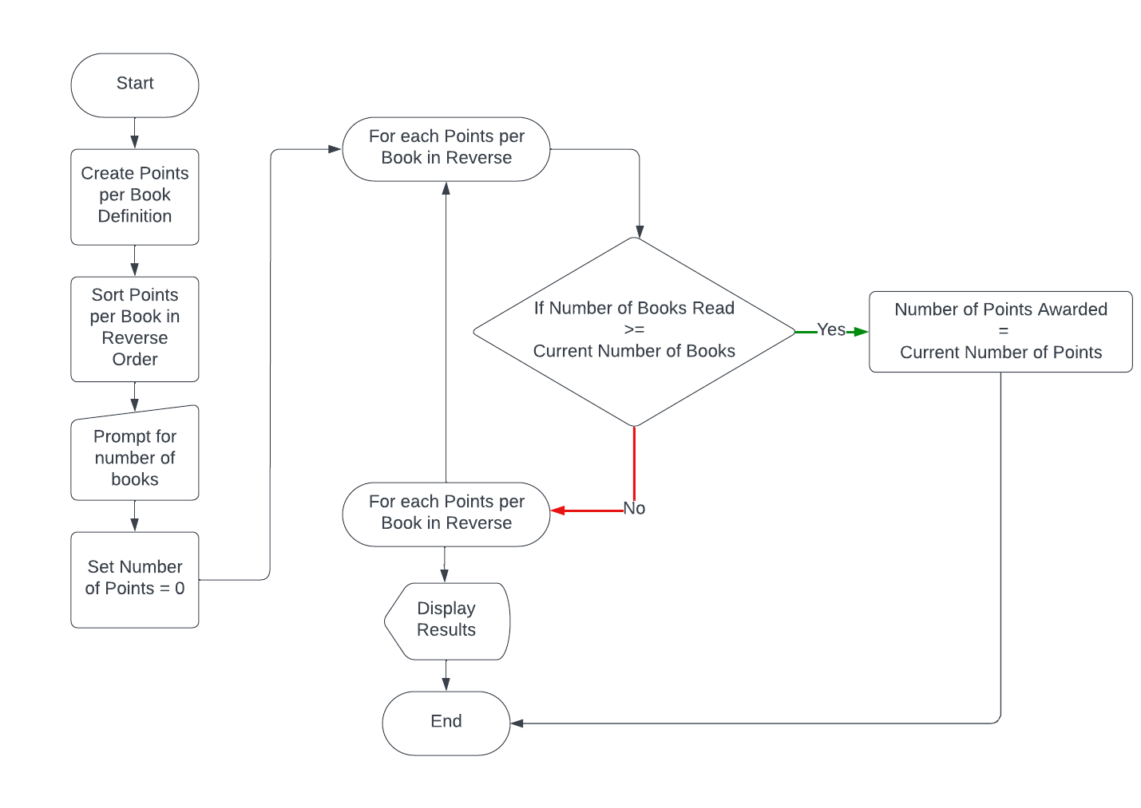

## Python Code

# The CSU Global Bookstore has a book club that awards points to its students based on the number of books purchased

# each month. The points are awarded as follows:

#

# If a customer purchases 0 books, they earn 0 points.

# If a customer purchases 2 books, they earn 5 points.

# If a customer purchases 4 books, they earn 15 points.

# If a customer purchases 6 books, they earn 30 points.

# If a customer purchases 8 or more books, they earn 60 points.

#

# Write a program that asks the user to enter the number of books that they have purchased this month and then display

# the number of points awarded.

# Define variables

num_points = 0

points = {

'0': 0,

'2': 5,

'4': 15,

'6': 30,

'8': 60}

# Reverse sort the dictionary

reverse_sorted_points = {}

for key in sorted(points, key=points.get, reverse = True):

reverse_sorted_points[key] = points[key]

# Get number of books

num_books = int(input('Enter number of books:\n'))

# Traverse through reverse sorted dictiony, break upon match

index = 0

for value in reverse_sorted_points:

if num_books >= int(value):

num_points = reverse_sorted_points[value]

break

index += 1

print('You earned {} points!'.format(num_points))

## Output

# Git-repo

<https://github.com/tlerunner/git-repo/tree/main/Module%205>